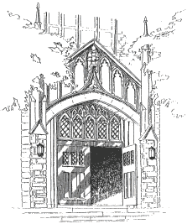
FIRST PRESBYTERIAN CHURCH OF OLNEY
THIRD STREET AND TABOR ROAD

PHILADELPHIA, PENNSYLVANIA 19120
www.FPCOlney.org
215-424-6809

PICNIC PERMISSION SLIP

________________________________ __________________________ __________________
Child Last Name Child First Name Nickname

______________________________________________________________
Address
____________________________ __________ ________________ ________________________
City State Zip Code Home Phone Number

→ My child has permission to go with the First Presbyterian Church of Olney to Burholme Park on Saturday, ______________.
- We will leave from the church at 11:30 and return around 5:15 p.m.
- Each child should bring a bag lunch and snacks.

_______________________________________ _____________________ __________________
Parent/Guardian Signature Date Phone Number

In case of emergency, please contact:

_________________________________________________ _____________________
Name Phone Number

If your child has any known allergies, please list them here:

____________________________________________________________________________

Please list your health insurance information: Company: ______________________________
Policy Number: __________________________ Group Number: ________________________
Policy Holder’s Name: _________________________________________________________________

